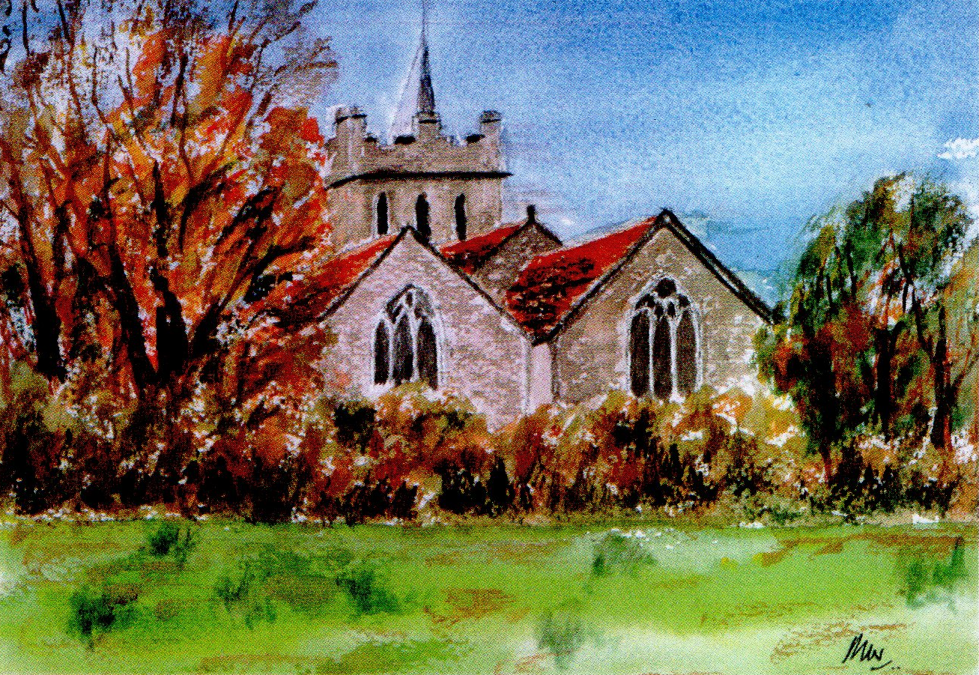
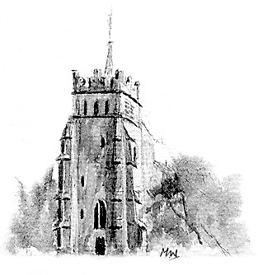
The Friends
of
All Saints Church
Ashdon
Michael Wymer
Wittenham Cottage
Ashdon
Saffron Walden CB10 2ET
Tel: 01799 584234

Email: Michael@mwymer.freeserve.co.uk
Registered Charity: The Friends of the Parish Church of All Saints, Ashdon in the Diocese of Chelmsford
Registration Number: 1099038
Secretary: A K Hawley, The Old Bakery, Ashdon, Saffron Walden CB10 2ETTel/Fax: 01799 584424 Email: tony.hawley@virgin.net
Registered Charity: The Friends of the Parish Church of All Saints, Ashdon in the Diocese of Chelmsford
Registration Number: 1099038

Registered Charity: The Friends of the Parish Church of All Saints, Ashdon in the Diocese of Chelmsford
Registration Number: 1099038

THE FRIENDS OF ALL SAINTS CHURCH ASHDON
Boozy Quiz 6 February 2021

I am not sure about dry January, but the dark days of January this year are perhaps darker than normal this year. So to bring some much needed fun and a chance to chat with friends old and new join us on Saturday 6th February 2020 for an evening with a bottle of wine and quiz in the comfort of your home.

We are pleased that Phil Knox, Ashdon's very own Lockdown Quiz King, has agreed to be quizmaster for a special evening brought to you by the Friends of All Saints Church. We will start with Justin Waples of Waples Wine (Great Sampford) giving us some highlights and points to note on a delicious red wine – Salice Salentino Riserva 2012 or 2013 - before Phil gets going with the quiz. We are still working on the questions, but expect to brush up your knowledge of:

- Ashdon
- Gen Knowledge
- TV/Movies/Music
- History/Politics
- Sport

The cost will be £12.50 per household – covering the cost of the wine and a small contribution to the Friends. We will look to deliver the wine to you in a socially distanced and safe manner prior to the 6th. The event itself will be via Zoom – if anyone has not used Zoom yet, I am happy to talk you through how to use it: a link will be circulated to those who are attending ahead of the evening. Start time is to be confirmed but the current plan is 7pm.

If you are interested in attending or would simply like to know more, send me an email simonhobday@yahoo.co.uk. Places are limited so don't wait!!

In the meantime, stay safe

Simon
Simon Hobday
Chairman of the Friends of All Saints Church

